**VDOM & RDOM**

* **VDOM & RDOM(Document Object Model)**
* **Diffing & Reconciliation**
* **Importance Of A Key Attribute In A List**

**VDOM & RDOM**

In React, the DOM(Document Object Model) and Virtual DOM are fundamentals concepts that play a crucial role in optimizing the performance of web applications. Here’s an overview of each concept:

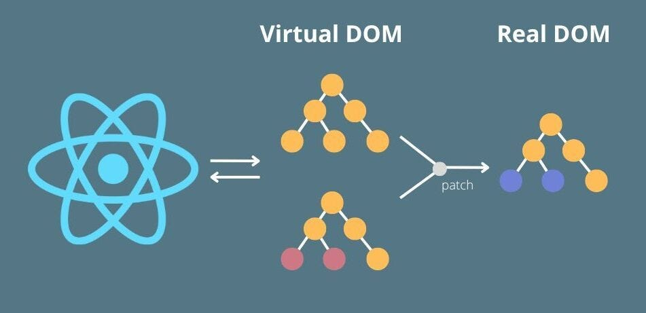

1. **DOM(Document Object Model):**

* The DOM is a programming interface that represents the structure of an HTML or XML document as a tree of objects.
* Each element in an HTML document, such as heading, paragraphs, buttons, and more, is represented as a node in the DOM tree.
* When a web page is loaded or updated, the browser constructs the initial DOM tree based on the HTML markup.
* Any changes to the content or structure of a webpage are reflected in the DOM, and these changes trigger a process called ‘reconciliation’ in which the browser updates the visible content on the screen.

**2. Virtual DOM:**

* The Virtual DOM is a concept introduced by React to improve the efficiency of updating the actual DOM.
* React creates an in-memory representation of the DOM called the virtual DOM. This representation is a lightweight copy of the real DOM.
* When there’s a change in a React component’s state or props, React doesn’t immediately update the real DOM. Instead, it first updates the Virtual DOM to reflect the new state of the component.
* After updating the Virtual DOM, React performs a process called ‘reconciliation’ to identify the differences between the old Virtual DOM and the new Virtual DOM.
* Once the differences are identified, React calculates the most efficient way to update the real DOM to match the new Virtual DOM.
* Finally, React applies the necessary changes to the real DOM, resulting in an update to user interface.

## The key benefits of using the virtual DOM in React are:

1. Improved performance: By minimizing direct, manipulation of the real DOM, React reduces the number of updates needed and increases the efficiency of the rendering process.
2. Batched Updates: React can batch multiple updates together and apply them in a single pass reducing the number of expensive real DOM operations.
3. Reusable components: Components in React are designed to be reusable and composable. The Virtual DOM helps manage the state and rendering of these components efficiently.
4. Cross-Platform Compatibility: React’s Virtual DOM abstraction allows for easier integration with different rendering targets, such as web browsers and mobile apps(React Native).

### **In summary, React’s virtual DOM is a critical optimization technique that minimizes the performance overhead associated with frequent updates to the real DOM, making it a key feature for building efficient and responsive web applications.**

We have a html page and we created elements using the js file where when you click the update time button it again creating the elements freshly removing the previous ones it will be a problem because creating again and again taking lot of storage that where react came up with concept of virtual dom where it saves the memory.

The images below show the real dom behavior:

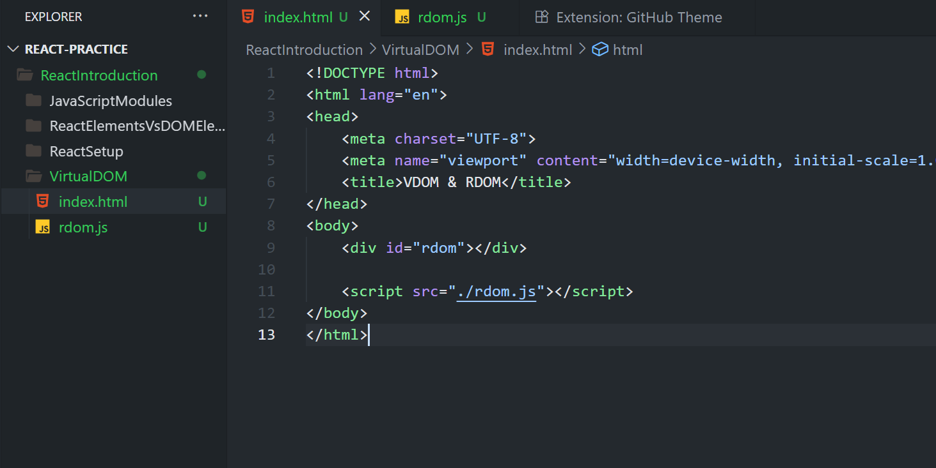

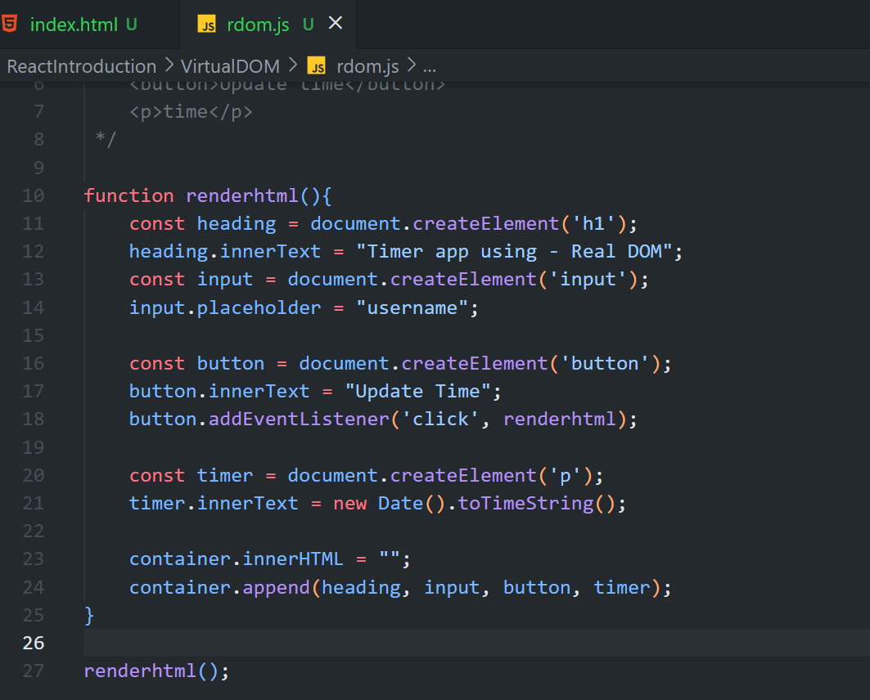

Below diagrams shows how we write the elements in the virtual dom behaviour:

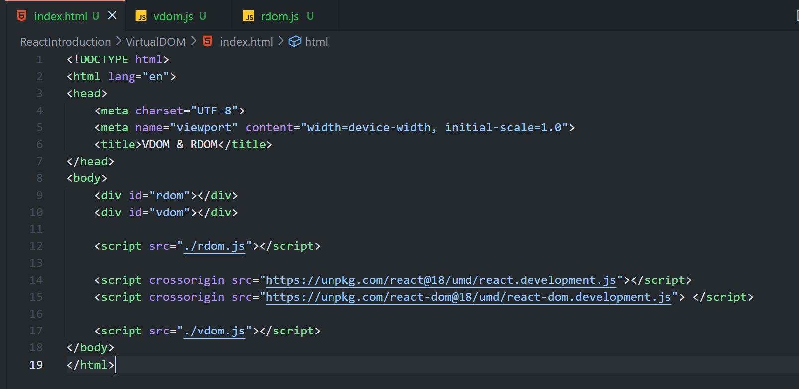

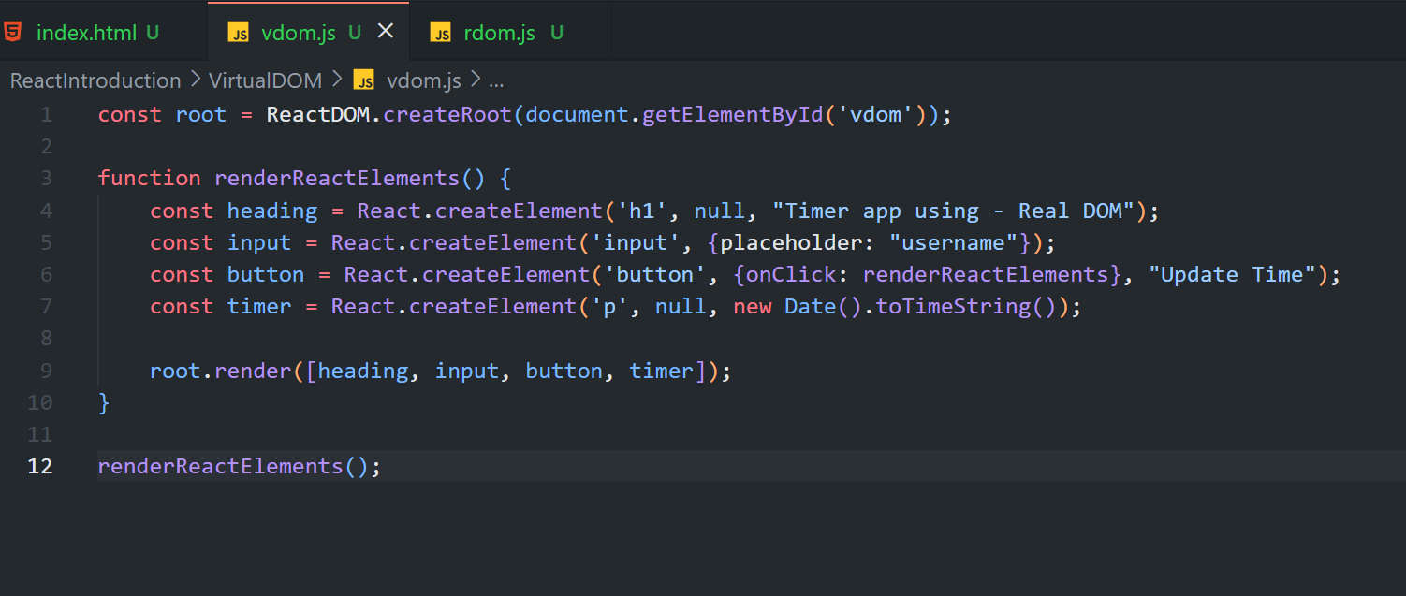

Firtst time we create the real dom and the react will create a virtual dom with the same elements of real dom(it will create in in-memory(inside memory) of a browser).

Next suppose some changes are made in the real dom then react creates another virtual dom with the changes and now it will not directly renders into the real dom.

It will check the changes with its previous virtual dom like you can think of it like as a virtual dom1 and virtual dom2 it compares presents changes we made virtual dom2 with virtual dom1.

If the changes made it check element like h1,p tags are there it will compare like h1 no changes have been made next if <p> has any changes it will only modify that element only don’t touch any of other elements then after checking everything perfect it will push to the real dom.

Simply It checks differences between elements.

This is how real dom and virtual dom work together.

To do all this process we have process or algorithm in background of browser called as **diffing algorithm** or process.

**Reconciliation:**

Reconciliation means after finding the differences it will push the changes to it’s real dom this process is known as reconciliation.

That’s why we use react it will excute fastly (takes millie or micro seconds) suppose you take vanilla javascript it is going to take more time and lazy loading will also happen right that’s why we use react.